(following user story is from Krauthammer Lab at Yale., as captured after the 11/23/2010 meeting. )

=====================================================

Priority – 1

User Story Title: Generic Data Type Support.

The basic idea here is to support gene-based genomic data that is not Gene Expression or Copy Number. They would like a generic way to specify platforms for, and the querying of, a generic platform and datatype. Their data is closely modeled to gene expression.

As a **platform manager** role, USBAT upload generic platform annotation file, and provide the datatype. (Current datatypes are copy number and gene expression.) USBAT see a new data type called “Generic”. Selecting Generic will present the user with an empty text box for providing a custom platform name. The file format will be the same as is currently used by Agilent Gene Expression. In addition to the file name to be uploaded, USBAT see a new field for providing the column name for the location of the platform’s reporter IDs. USBAT see a new field for providing the column name for the generic data type’s Data Value.

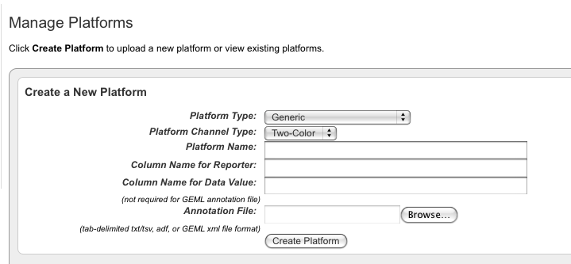

As a **study manager** role, USBAT select a platform of generic type on the Configure Genomic data source screen, similar to the way Gene Expression and Copy Number platforms are selected. USBAT select “Data Type = Generic” and “Vendor=Generic”. Selecting “Data Type = Generic” will display the list of custom platform names. The “Array Data Loading Type” will be “Supplemental Single” and “Supplemental Multiple.”

As a **study investigator** role, USBAT see a link in the left menu for “Data Plot”. This link will function very similarly to “Gene Expression Plot” with one key difference being that that on the page, the user will select which generic platform, they would like to plot.

As a study investigator role, USBAT see a new query criteria for the generic data type that they have added.



